

To: City Executive Board

Date: 13th February 2013

Report of: Head of City Development

Title of Report: FOOTPATH CROSSING THE RAILWAY AT ARISTOTLE LANE

Summary and Recommendations

Purpose of report: Network Rail is proposing to make substantial investment in Oxford station and the main line rail network between Southampton and the Midlands. To support this investment it is seeking agreement from the City Council to close the footpath crossing the railway at Aristotle Lane.

Key decision? No

Executive lead member: Councillor Colin Cook

Policy Framework: Economy

Recommendation(s):
The City Executive Board is recommended to:

1. surrender such rights the City Council has in respect of the footpath crossing the railway between Aristotle Lane and the Trap Ground allotments by a Deed of Release.

2. only permit the footpath to be closed once Network Rail has provided, in consultation with local stakeholders, the promised improvements to the Aristotle Lane footbridge, the provision of a new car park on Council land at Aristotle Lane and the provision of a permissive footpath over its land to the Trap Grounds (Town Green).

2. instruct the Head of Corporate Assets to complete negotiations with the County Council to transfer part of the City Council’s land to the Saint Philip and Saint James Primary School.

Background

- In 2002 the Council considered this matter of the footpath crossing at the time of the renewal of allotment leases. The Executive Board on 29th July 2002 considered a report on the Trap Grounds – Access to allotment land.

- It resolved:
“To proceed with the transfer of the land to be used for school purposes, excluding a perimeter strip, in order to enable continued access to be provided over the railway line direct to the allotments.”

- In 2010 the Council was asked to consider whether to lodge an objection at the time of the Chiltern Railway Transport and Works Act Inquiry. Full Council on 19th April 2010 considered a report on Land at Aristotle Lane, Trap Ground Allotments and Port Meadow: Chiltern Railways Transport and Works Act Application.

- The Council resolved:
“To confirm and endorse the detailed objections to the scheme, as set out in the letter dated 15tth February 2010
To note that discussions would continue with Chiltern’s agents with a view to reaching solutions to overcome the objections. “

- The Chiltern Railway Inspector published an interim report following the Inquiry. He made a number of comments in reaching his recommendation that the footpath crossing could be retained:
- The harm avoided by not building the proposed level crossing (over the new Chiltern rail lines as proposed by the objectors) would remain very slight, unless East West Rail went ahead,(my emphasis) in which case it might be effectively more.
- I therefore attribute very slight weight to the harm that the scheme proposal would avoid until East West Rail proceeds.
- I note the options identified by allotment holders for enhancing safety at the level crossing, the implementation of which seems to me consistent with the Office of Rail regulation’s policy. (selective quotations only)

- On 17th October the Secretary of State for Transport made the Transport and Works Act Order and granted deemed planning permission for the Chiltern Railways Bicester to Oxford Improvements. In the decision letter the Secretary of State explains that “he remains satisfied that for the reasons given in the main (Inspector’s) report that it is appropriate to retain this (the Aristotle Lane crossing) private accommodation crossing for use by allotment holders”.

- There are, however, a number of interrelated proposals for substantial investment in the rail network as it passes through Oxford, including:
- Electrification and signalling improvements of the Western Main Line up to and including Oxford Station.
- Deployment of Super Express Trains (90 mph) for the London to Cotswold Line services
- Completion of gauge-enhancement of the Southampton –West Coast Main Line (in 2011) with increasing freight train lengths up to 775m
- An extra fourth railway line and the freight lengthening scheme (passing loop) past Port Meadow to give the necessary freight / passenger train segregation.
- An extensive electric spine between Southampton to the West Coast Main line.
- A redeveloped station at Oxford together with a new Botley Road bridge
- Chiltern’s Evergreen III proposals to link Oxford to Marylebone, and the completion of East West Rail and the inclusion of a double junction connection at Oxford North. This may necessitate a fifth railway line.

- The effect of this investment will mean significant changes to the rail environment at Aristotle Lane with at least an additional railway line to be crossed (the total number of lines will be 4, but maybe 5), trains going past at 90 mph (currently limited to 70mph), very long (0.75 km) slower moving freight trains (obscuring sight lines especially of passenger trains on the western most line) and Evergreen III then East/West Rail trains running in either direction on the eastern most pair of lines. In total there could be 22 trains in the peak passing Aristotle Lane by 2015, an increase of some 50%.

Request from Network Rail

- As a result of this significant investment, as summarised above, affecting the Oxford rail corridor, Network Rail and the Department for Transport (DfT) have reviewed the footpath crossing arrangements at Aristotle Lane, with a review of the crossing risk assessment and consideration of whether there are any options to retain the crossing to acceptable levels of safety.

- Network Rail is firmly of the view that, even if there were footpath crossing improvements at Aristotle Lane, such as mini stop lights, the risks to users and rail safety would remain totally unacceptable. This is backed up by Her Majesty’s Inspector of Railways. It believes that there are no acceptable crossing improvement options available to mitigate against these risks. As a result it is proposing that the alternative crossing must be via the existing Aristotle Lane Footbridge (occasionally called Willow Walk by Network Rail). It is proposing to improve this footbridge including increasing its height to accommodate future electrification of the railway.

- Therefore Network Rail is asking the City Council, as the owner of the crossing rights to the private footpath crossing, to agree to a Deed of Release to surrender such rights the City Council has so that the crossing can be closed. In return it is proposing improvement works to Aristotle Lane Bridge and environs as listed below.

- Network Rail has advised the City Council that it appreciates that the allotment owners, for whom the crossing is maintained, have concerns about the permanent use of the footbridge as an alternative method of crossing the railway. It is aware of the previous concerns that were raised during the Transport & Works Act (TWA) application for the Evergreen III (EG3) project. Therefore, its detailed proposals to improve the bridge have attempted to address these concerns.

- The proposals, therefore, are to rebuild the Aristotle Lane footbridge to a clear height of 4.78m for electrification purposes and to improve the approach ramps with a consistent gradient and surfacing that, as far as practicable within the site constraints, provide compliant mobility impaired access across the railway. In due course it will seek planning permission from the City Council for these works.

- The proposed works also include;

- a new car park area adjacent to the east approach ramp (seeking to release as much land as possible for St Phil & Jim School extension proposals)
- new access steps from the car park up the north face of the east approach ramp.
- The option of a new allotment access ramp from the west approach ramp, if desired by the allotment holders,
- raising the lower section of the west approach ramp to improve dry access, if requested.

- See attached plans as appendices, one and three.

- Network Rail has said that it is very willing to work with the City Council and the local stakeholders to agree the details of these proposed works because it is seeking to satisfy the wishes of all as far as possible. Therefore CEB are not being asked to decide on these proposed works at this time.

- A 75 page report prepared by Atkins, as consultants, for Network Rail, on the Aristotle Lane Crossing is available to view on the Council’s web site as a background document to this committee report.

- Following completion of the above, the Aristotle Lane crossing would be closed and secured from future use by removal and fence line modifications.

- Network Rail and the Department of Transport have made it clear to the City Council that retaining the Aristotle Lane crossing would, theoretically, prevent the Government’s enhancement plans for the Oxford area and transport corridor from going ahead and thus fail to deliver the full benefits of the investment to rail and non-rail stakeholders in the region and nationally.

- In practice, since these investments are so critical, if the City Council were not to agree to surrender its rights so that the crossing can be closed Network Rail or the DfT would need to consider alternative, possibly legal, remedies.

Network Rail’s Assessment of Risks associated with the footpath

- The Atkins report records that:

“the planned future increases in crossing length, train frequency and line speed will increase the required warning time for potential users of the Aristotle Lane crossing to 29.85 seconds, compared to the existing 18 seconds of warning time currently afforded by the existing whistle boards. (This figure does not include the further restrictions caused by stationary or slow moving freight trains). At the same time visual sighting of approaching trains would become more inadequate at the footpath crossing, thus placing even greater reliance on the whistle boards. However these would need to be placed at such a distance that in fact the train horn would be inaudible from the crossing. Therefore taking the above factors into account, Network Rail rejects the possibility of continuing Aristotle Lane as a passive crossing within an enhanced track layout. Whistle boards would have to be too far away for train horns to give effective warning, and the frequency and pattern of train movements on the reversibly signalled lines will make it unacceptably complex for users to decide whether it is safe to cross.”

- Network Rail has considered but rejected both miniature stop lights and fully controlled (barrier) method options and is firmly of the opinion that both are inappropriate for this location. Such measures are not appropriate on more than a two track railway. A central reservation in the middle of 4 tracks does not overcome the safety objections. It has decided that, as no acceptable arrangement for a footpath crossing is available, there is no basis upon which a detailed risk assessment could be carried out for the crossing with the enhanced track layout.

Mitigation offered (see also Appendix 5)

- Network Rail’s consultants have assessed those matters that were raised at the Chiltern Railway (Evergreen III Inquiry as criticisms of the proposal to use the Aristotle Lane bridge. It is Network Rail’s view that these concerns can be overcome with its proposed works to the bridge, its ramps and environs which go further than what was offered by Chiltern Railway at that time. It is offering to:
- Provide a much smaller increase in the distance to travel from the car park to the allotments via the Aristotle Footbridge
- Overcome the lower west approach problem of flooding and water flows
- Mitigate dog fouling that affects allotment users
- Provide a west side connection ramp to the allotments in a way that does not restrict cow movements, if desired.
- Agree with all users the most appropriate surfacing standards and gradient for the footbridge and ramps.
- Permissive footpath up to the Trap Grounds.
- Fully address the constraints set by the SSSI status of Port Meadow and the right of the Freemen.

- The City Council already allows some limited vehicular access from Walton Well Road through Port Meadow to the Allotment site and this could continue when the footpath crossing is removed. It is understood that skip lorries, compost deliveries and other trips already use this access on an agreed basis.

Legal implications

- Liability under the Occupiers Liability Act 1984: Liability to trespassers and the allotment holders is regulated by this Act. In this case the City Council as the owner of the land owes a duty of care to anyone entering the allotments by crossing the railway, even if they do so without permission, such as young people. This duty of care means that the City Council must take such care as is reasonable in all circumstances to see that they do not suffer injury. In recent months code controlled gates have been installed.

- In this instance the City Council is already aware of the potential danger, particularly because this has been pointed out by Network Rail and the HM Inspector of Railways. It must be concluded that the potential adverse legal, financial and physical risks far outweigh any benefits of keeping this footpath crossing open.

- Corporate Killing and Involuntary Manslaughter, City Council Liability: It is not the intention to be alarmist in respect of this liability, however the worst case scenario is that, if as a result of the City Council allowing the crossing to remain open, someone is killed, the Members of the CEB could be held personally liable.

- Allotment Lease: The lease of the allotments by the City Council to the Trap Grounds Allotment Association was not renewed as was envisaged at the time of the 2002 committee report (albeit the rent payable was reviewed) and they have been allowed to hold over since and this remains the status. Since September 2002 the right of access across the footpath crossing has been ended by a notice serviced by the City Council at the time. Should the allotment association wish to take a new lease of the allotment land the City Council has always made it clear that the permitted access will be provided via the Aristotle Lane public footbridge

- The original lease from 1987 (under which they are holding over) did include part of the land and the rough roadway on the Aristotle Lane side of the railway but this was surrendered by the Trap Grounds Allotment Association in 1994 although they do retain a right of way on foot only over the roadway.

- Once the Aristotle Lane Bridge is improved and the footpath crossing closed a new lease should be offered to the Allotment Association or sooner if they so request.

- Deed of release: It is proposed that an appropriate Deed of Release should be drawn up and agreed in draft with Network Rail. However the Deed should not be granted until after the improvements to the Aristotle Lane Bridge have been carried out and the Bridge re-opened to public use.

- A land ownership plan at appendix 2 should help understand the next few paragraphs.

- Permissive Footpath up to Trap Grounds Town Green: It is suggested that part of the negotiations with Network Rail should include an appropriate legal agreement to confirm the use of a footpath over its land from Aristotle Lane north to the Trap Grounds.

- Proposed car park and control over usage: It is suggested that there will also need to be negotiations with Network Rail to allow them to construct a new car park on City Council land and gain a new point of access to rail land through this car park, and completion of associated agreements.

- Lease of land to Phil and Jim school: Once the footpath crossing is closed, a new car park provided and the footpath to the Trap Ground Town Green established, there is a triangle of land in City Council ownership that is of interest to Saint Philip and Saint James Primary School. The Council has for some time been discussing the transfer of this land to the County Council for an extension to the site of the primary school, to expand its open space. Members are asked to agree to instruct the Head of Corporate Assets to complete negotiations with the County Council to transfer part of this City Council’s land to the Phil and Jim School.

Consultation

- A meeting was held with those listed below on 12th November at which Network Rail outlined the proposals for the Oxford corridor and their plans in particular for improving the Aristotle Lane Footbridge.
  - Local Councillors
  - Trap Grounds Allotment Association
  - Freemen of Oxford
  - Port Meadow Protection Group
  - Oxfordshire County Council
  - Phil and Jim School
  - The Friends of the Trap Grounds
  - BBOWT
  - Natural England
  - Waterside and Waterways Residents Association

- A meeting for the public was held on 9th January 2013 at which Network Rail again outlined its proposals for the Oxford Corridor. About 100 people attended the meeting and were able to ask a wide range of questions.

- To date the City Council has received comments from the following:

- Phil and Jim School (from the Chair and the Headteacher)

SS Philip & James' Primary School are in support of the Network Rail proposal to close the level crossing at Aristotle Lane. It believes that the existence of this crossing is a hazard so close to a primary school attended by more than 400 children. Last summer it was reported to the school that children had been seen on the level crossing. It was not certain that these were children from its school. However the school regarded the issue as extremely serious, and invited Liz Heading from Network Rail to come and address the older children on 25 June about the danger of playing on or near the railway lines.

The location of the Trap Grounds Allotment Association (TGAA) replacement parking is of great importance to the school because it has been recognised since the school was built that there is a shortfall in the play area. The inclusion of a triangle of land to the south of the school will provide an additional area up to 1055 m2, if the TGAA parking is re sited.

- Trap Grounds Allotment Association Committee (from the Chairman)

It has kept its members up-to-date regarding matters concerning the rail crossing. When it last carried out a survey 88% of the respondents were in favour of the crossing remaining open. (There are 222 members of the Association of whom only 7 live outside our catchment area.) It would be very unhappy if the crossing were to be closed. In its view, to close the crossing would be like using a sledgehammer to crack a nut. Whatever risks there are could be reduced to something acceptable to all reasonable parties by means other than closure such as additional safety features at the crossing like warning lights. It would, of course, welcome the cessation of the sounding of horns by passing trains. The recent addition of a locked gate prevents unauthorised access to the crossing.

The local railway improvements should improve people’s lives without unnecessary bureaucratic interference with reasonable freedoms

- Waterside and Waterways Resident Associations (on behalf of the two chairmen)

The only losers to the current proposals for investment in the railway are its 3,000 residents who will suffer a significant loss to their quality of life by potentially having many more trains thundering through every three or four minutes. The only glimmer of hope has always been that the closure of the Aristotle Lane footpath crossing would result in the end of the need to sound warning horns, which the residents suffer from as early as 6am, up to as late as midnight most days. Their lives would become almost unbearable if they were subject to these horns every few minutes.

- Natural England (from Oxon and Bucks Land Management Team)

It had a good meeting with Network Rail in December 12. The key projects for Natural England seem to be the Aristotle Lane footbridge and the suggestion of tree planting alongside the line at Wolvercote. For the footbridge, Network Rail it to come up with a Method Statement to explain how it intends to do the work. For the tree planting at the Wolvercote end, Natural England has said ‘no’.

Risk Assessment

- A risk assessment is attached as appendix four. It highlights the risks, flowing from not agreeing to surrender the rights so that the footpath can be closed, that could include death or serious injury of allotment holders on crossing and an impact on Oxford’s economy through a withdrawal of investment by Network Rail.

Climate Change

- There is the potential for significant improvements in the impacts of the railway through electrification, which produces less noise and pollution. The potential to secure a significant diversion of freight off the road , especially the A34, and onto rail should again have important climate change benefits.

- The impact on the SSSI of Port Meadow is anticipated to be kept to an absolute minimum, such that in carrying out the actions recommended Network Rail and the Council will take reasonable steps, consistent with the proper exercise of the Council’s functions, to further the conservation and enhancement of the flora, fauna or geological or physiographical features of which the Meadow is an SSSI.

Equalities Impact

- It is suggested that it is reasonable to assume that if allotment holders are fit enough to work an allotment they are also be fit enough to push a wheelbarrow over the footbridge which will have ramps that are DDA compliant. Although, alternatively, it might be considered that the revised access route to the allotments, which would not be level, would potentially increase the difficulty of reaching it for some allottees.

- With the footpath crossing closed there will no longer be a need for the trains to sound their whistle. It is suggested that this will bring widespread benefits to local residents and the children at the school.

Financial Implications

- All the proposed changes to close the footpath crossing and improve the Aristotle Lane footbridge, plus related legal costs will be wholly at Network Rail’s expense, with no financial liabilities falling on the City Council.

- Depending on the outcome of the negotiations with the County Council the City Council may receive a financial receipt for the transfer of land to the Phil and Jim Primary school.

Conclusion

- It is recommended that the Committee should agree to the request to surrender its rights so that the footpath can be closed through the associated Deed of Release. It is accepted that there will be some disadvantage to the Aristotle Lane allotment holders, however Network Rail is proposing to improve the Aristotle Lane Bridge which will provide a suitable alternative. It is also willing to work with the City Council and local stakeholders over the details of such improvements.

- Overall however it is considered that the City Council has no real choice. The impact though keeping the crossing open would be substantial. Her Majesty’s Inspector of Railways would never sanction going ahead with the proposed Oxford Rail Corridor network changes whilst the footpath remains open because the level of risks are completely unacceptable. Therefore Network Rail would either not proceed with its investments in the network, as funded by DfT, or it would instigate alternative, possibly legal, remedies.
.

Name and contact details of author:-
Name: Michael Crofton Briggs
Job title: Head of City Development
Service Department: City Development
Tel: 01865 252360 e-mail: mcrofton-briggs@oxford.gov.uk

List of background papers:
Aristotle Lane Crossing. Grip 3 Option Selection Report by Atkins for Network Rail.
Revised set of plans since the Atkins report

List of appendices:
  - Location Plan
  - Land ownerships plan
  - Proposed general arrangements
  - Risk assessment
  - Mitigation offered
  - Questions and Answers (attached as separate document)
  - Office of Rail Regulator – extract from website, policy on level crossings (attached as separate document)

Version number: 6 18 Jan 13

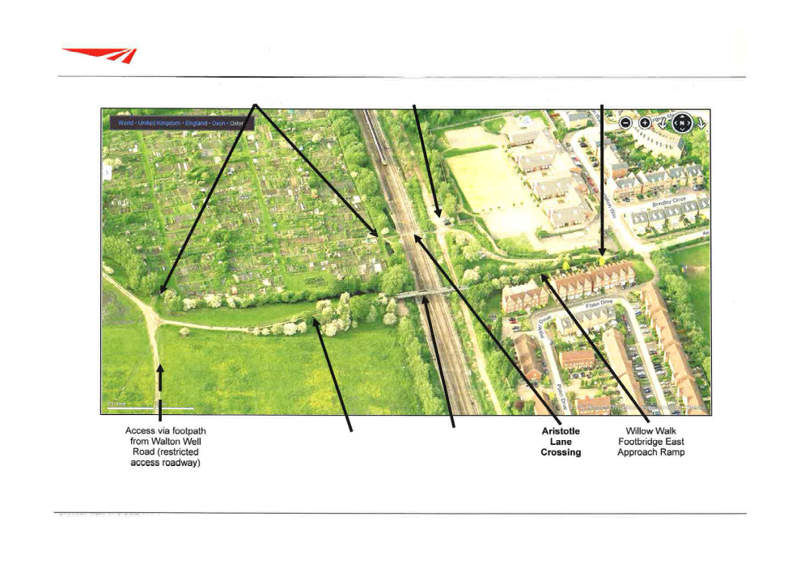
Appendix One: Location view of Aristotle Lane Crossing
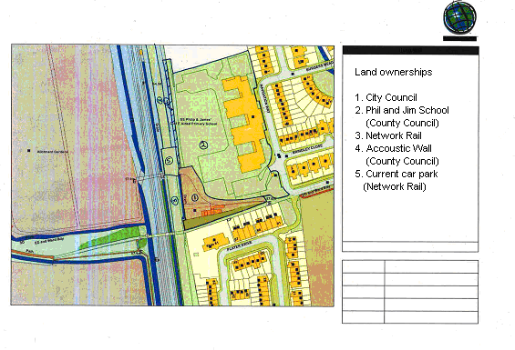

Appendix Two: Aristotle Lane Land Ownerships
Appendix Three: Proposed General Arrangements 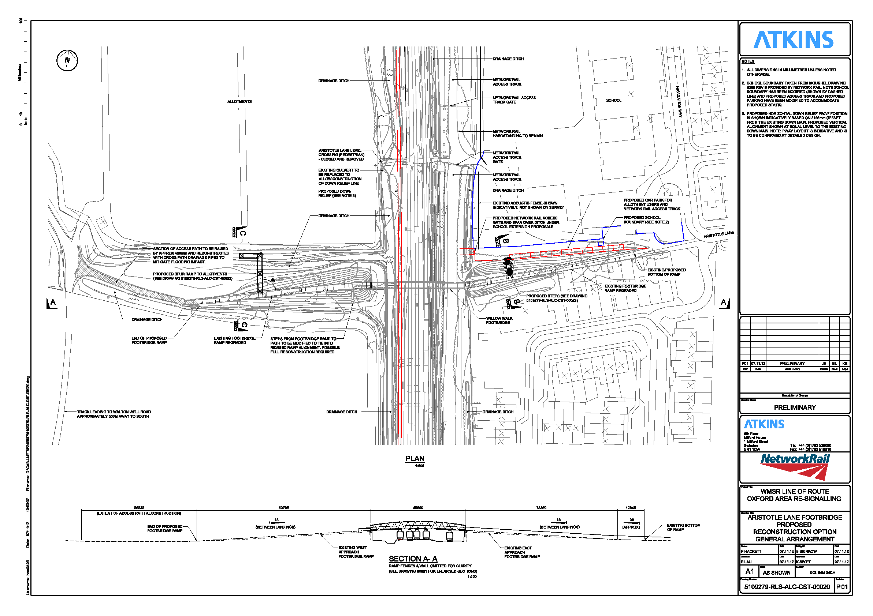
Appendix Four: Risk Assessment
No. | Risk Description  Link to Corporate Obj | Gross Risk |  | Cause of Risk | Mitigation | Net Risk |  | Further Management of Risk:  Transfer/Accept/Reduce/Avoid |  | Monitoring Effectiveness |  |  |  | Current Risk
 |  | I | P |  | Mitigating Control:  Level of Effectiveness:  (HML) | I | P | Action:  Action Owner:  Mitigating Control:  Control Owner: | Outcome required:  Milestone Date: | Q  1  ☹😐☺ | Q  2☹😐☺ | Q  3☹😐☺ | Q4☹😐☺ | I | P
1 | Death or serious injury of allotments holder or other person on the railway line | 4 | 3 | Accident on footpath crossing leads to successful legal proceeding | Mitigating control: Surrender rights so footpath can be closed  .  Level of Effectiveness: H | 2 | 1 | Action: CEB  Action Owner: M Crofton Briggs  Mitigating Control:  I.  Control owner: Michael Crofton-Briggs | Outcome required:  Milestone Date:
2 | Loss of investment in Oxford’s economy | 4 | 3 | Withdrawal of investment by Network Rail. | Mitigating control: Surrender rights so footpath can be closed  .  Level of Effectiveness: H | 1 | 2 | Action: CEB  Action Owner: M Crofton Briggs  Mitigating Control:  I.  Control owner: Michael Crofton-Briggs | Outcome required:  Milestone Date:
3 | Reputational Risk | 3 | 4 | City Council received criticism (bad press), locally, regionally and nationally for not closing the crossing | Mitigating control: Surrender rights so footpath can be closed  .  Level of Effectiveness: M | 2 | 2 | Action: CEB  Action Owner: M Crofton Briggs  Mitigating Control:  I.  Control owner: Michael Crofton-Briggs | Outcome required:  Milestone Date:

Appendix Five: Mitigation offered by Network Rail in Atkins Report

This is a summary of the assessment made in the Atkins report for Network Rail of those matters which were raised as concerns at the Chiltern Railway (Evergreen 3) Inquiry. The intention is to demonstrate how the current proposal is an improvement on that put forward by Chiltern to the Inquiry. The matters covered are:

- Increase in the distance to travel from the car park to the allotment via the Aristotle Lane (Willow Walk) Footbridge
- Lower west approach flooding and water flows
- Dog fouling by public users affecting allotment users
- Proposed allotment connection ramp restricting cow movements
- Surfacing standards and gradient

Increase in Travel distance

Existing Travel Distance:
Route A, from the existing hardstanding car park area to an arbitrary point a short distance inside and along the central allotment path via the level crossing, is 113m.
Route B, from the entry point off Aristotle Lane to the same point within the allotment via the level crossing, is 240m

Proposed Travel Distance:
Route C, from the proposed new car park area via the new east staircase and new west connection ramp, is 207m
Route D, from the entry point off Aristotle Lane to the same point within the allotment via the new west connection ramp, is 283m
The increase in travel distance between Route A & C is 94m.
The increase in travel distance between Route B & D is 43m.

Given the increase in risk to users of the level crossing under the proposed track layout, these increases in additional travel distance are not considered an unreasonable addition for a significant safety benefit.

Lower west approach flooding and water flows
The proposed design presented by Network Rail uses larger precast concrete sections to provide a flow route below the raised path. It is also believed that flood water will level out via the network of streams/ditches in the area and raising this section of the path should not impact the ground water flow in the area.

Dog fouling by public users affecting allotment users
The proposed solution includes the addition of dog bins and signage at either end of the path to help minimise the impact. However this will be subject to agreement with the Oxford City Council due to requirement to maintain and empty the dog bin facilities.

Proposed allotment connection ramp restricting cow movements
The revised proposal presented here moves the position of the allotment connection ramp, revises the gradient and provides between 1.6m and 1.8m clearance over a 7m wide section below the centre of the span, allowing animals to pass beneath to find shade.

Surfacing standards and gradient
The existing path over the bridge is mud/consolidated fill, on a relatively constant gradient, but currently has a ‘step’ onto the concrete edge to the bridge timbers, with a steeper ramp up to the level central bridge deck.

A clear width of 2m in accordance with BD29/04 is easily achievable and required to allow wheelbarrow users to pass on the route but the reduction in vegetation (to achieve the 2.0m width) may make the route appear less rural.

The proposed option shows the existing approaches regraded and resurfaced with a well graded compacted fill. The detailed design development should consult the interested parties if the surfacing of the path should be upgraded to a bitumen surface on the east approach (it is assumed this would not be desirable on the west approach due to its rural surroundings within the Port Meadow area). Increasing the clearance below the main span by jacking for electrification purposes will result in the east and west approach gradients becoming 1:13, therefore in accordance with BD29/04 regrading is to include 2m long landings every 0.65m rise.

Therefore at outline and detailed design, NR may wish to debate with local disability access groups the appropriate solution in terms of landings and allowable gradient versus extent of earthworks. For access to the allotments wheelbarrows and ‘pushed’ bikes will not roll back or run away, so there may be a case (with user and local authority agreement) that a constant gradient with no/fewer landings is better than the steeper/level/steeper/level 1:13 ramps proposed.

